**Orders Data Set:**

**Count of Order ID per customer:**

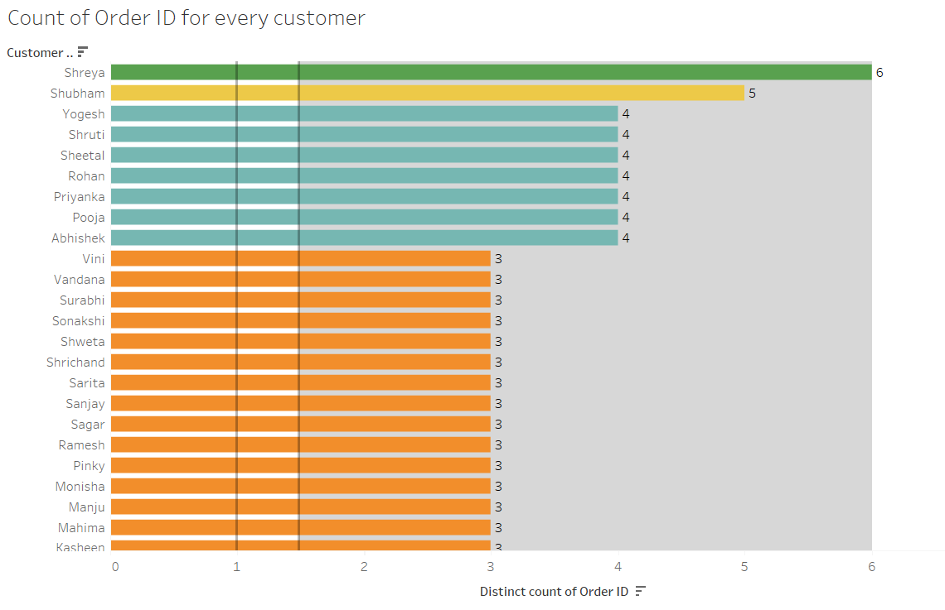

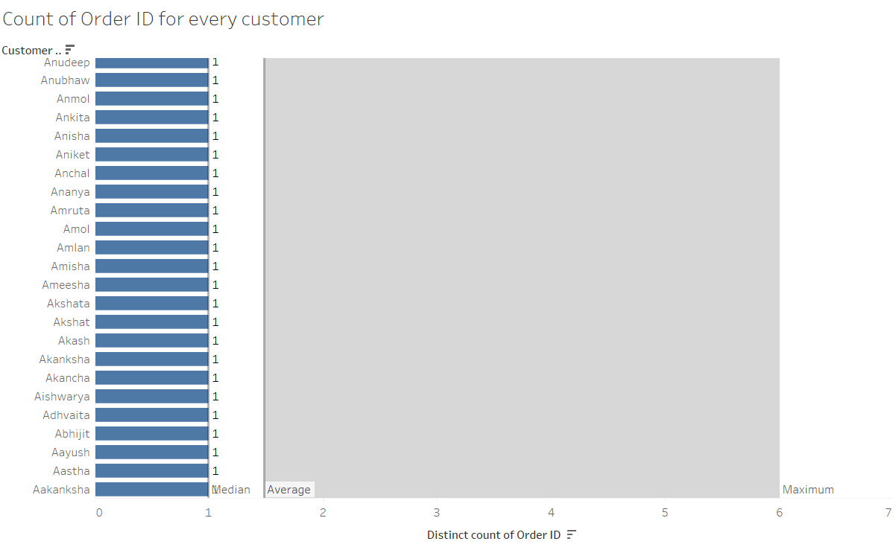

The maximum number of orders for any customer is 6 and the minimum number of orders for any customer is 1. The median number of orders is 1 and the average number of orders is 1.5. We can infer that maximum number of customers have ordered only once.

**Count of Order ID per quarter in the year 2018:**

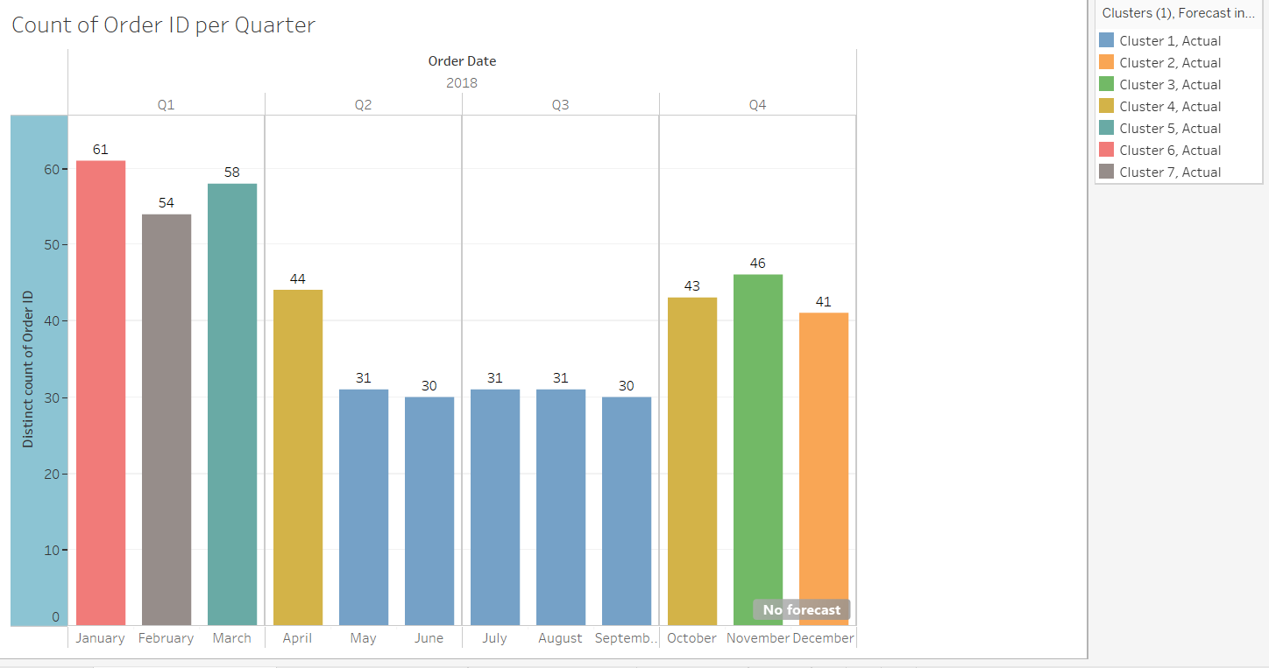

Maximum number of orders have occurred in Quarter 1 of 2018, in January. Minimum number of orders have taken place in Quarter 2 and Quarter 3, in the months of May, June, July, August and September. Quarter 1 and then Quarter 2 have performed well.

**Number of customers per state:**

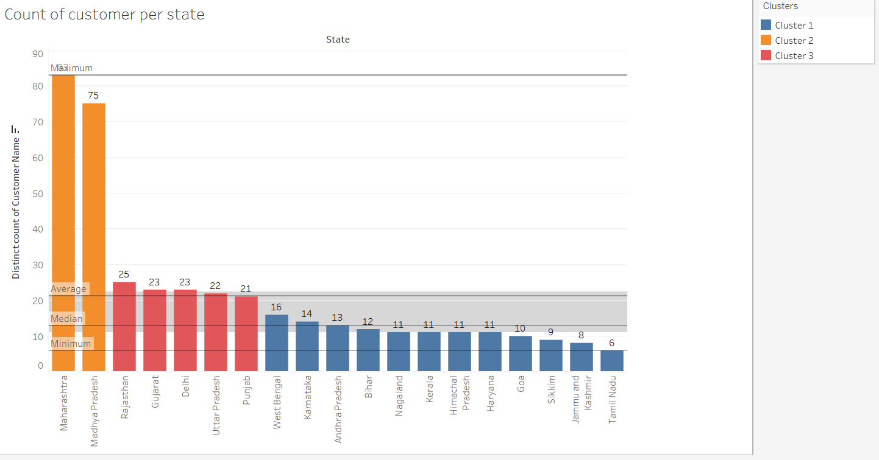

Maximum number of customers who have ordered are from Maharashtra and then Madhya Pradesh. Least number of customers have ordered from Tamil Nadu, J &K, Sikkim and Goa.

**Number of orders per state:**

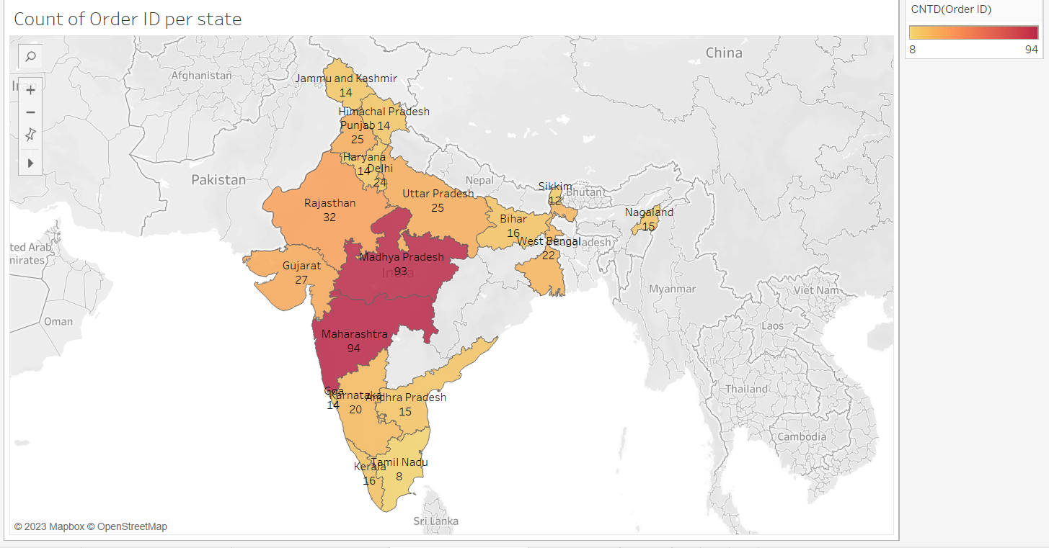

Maximum number of orders are from Maharashtra (94) and Madhya Pradesh (93). Minimum number of orders are from Tamil Nadu (8) , Sikkim (12), Nagaland (15), and Kerala (16).

**Percentage of orders per state:**

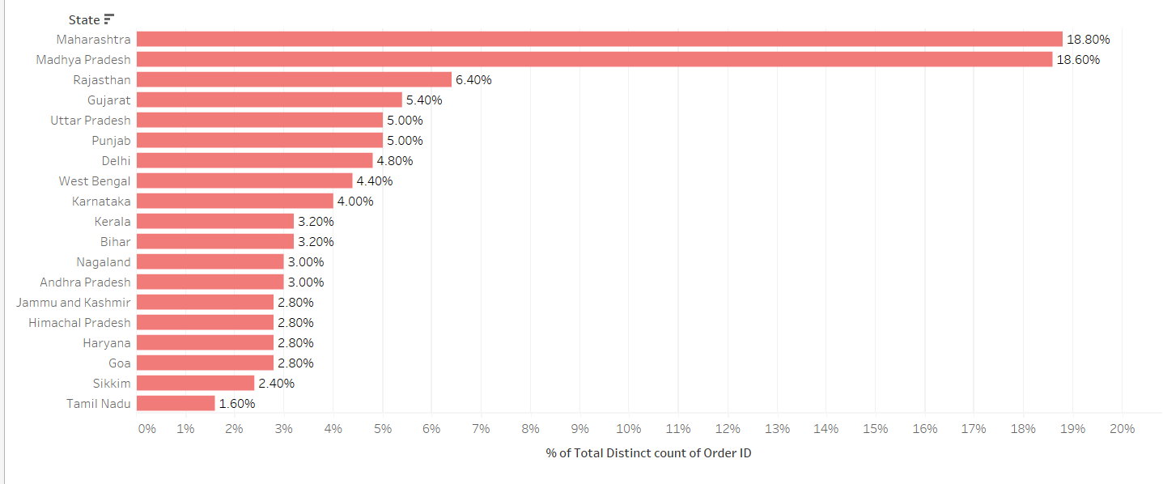

Maximum percentage of orders are from Maharashtra (18.80%) and Madhya Pradesh (18.60%). Minimum percentage of orders are from Tamil Nadu (1.6%), Sikkim (2.4%), and Goa (2.80%).

**Final Dashboard:**

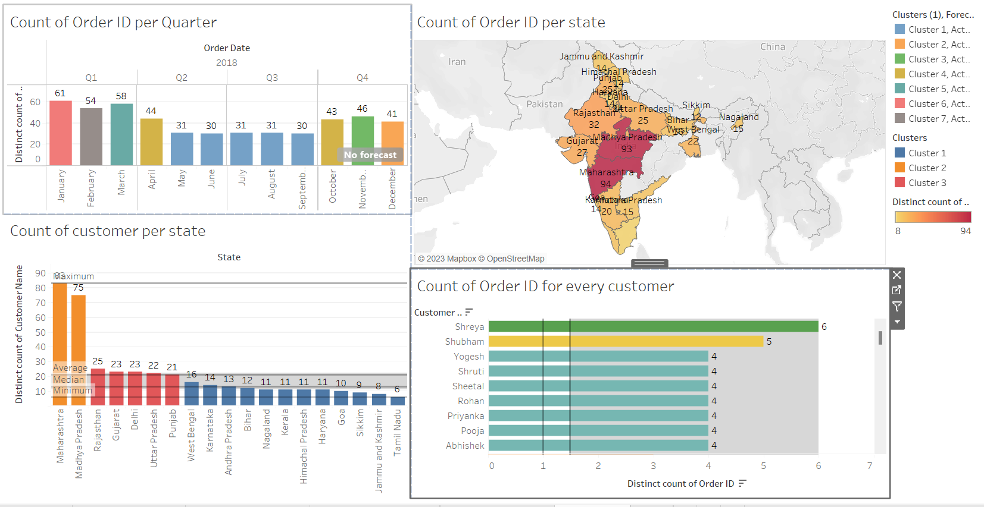

**Major Inferences:**

* Maximum number of customers who have ordered are from Maharashtra and Madhya Pradesh
* Maximum number and percentage of orders are from Maharashtra and Madhya Pradesh
* Both the median and average number of orders per customer are 1, hence it can be inferred that maximum number of customers have ordered only once.
* Maximum number of orders have taken place in Quarter 1 , in January
* Minimum number of orders have taken place in Quarter 3 and Quarter 4 in the months of May, June, July, August and September.

**Tableau Public Link:**

[**https://public.tableau.com/views/Top_Mentor_26th_March2023_AdvancedWeek1_Orders_Set/Dashboard1?:language=en-US&publish=yes&:display_count=n&:origin=viz_share_link**](https://public.tableau.com/views/Top_Mentor_26th_March2023_AdvancedWeek1_Orders_Set/Dashboard1?:language=en-US&publish=yes&:display_count=n&:origin=viz_share_link)